Lab Arrays

Using the Gosu Scratchpad, you will write Gosu code that extracts array members. For each task, write code in the Gosu Scratchpad that accomplishes the task. Save the code in to a .gsp file when you are done (In Studio, Refactor 🡪 Copy).

Tasks

1. Using the application UI, add two bank accounts to the ABContact Eric Andy and two accounts to William Andy. Create the bank accounts in the following ways:
   * William Andy: Set two of them to "Acme Credit Union". One should be checking and one savings.
   * Eric Andy: Set two to "National Bank". One should be checking and one savings

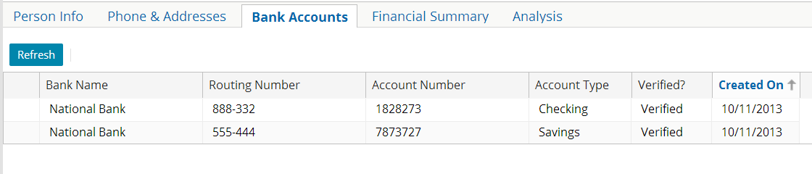

1. Print the number of bank accounts that the contact has.
2. Print a list of the account number and account type for each bank account.* Items in the list should be numbered and the numbering should start at 1.
3. Print the string "This contact has an National Bank account." if there is at least one account in the array with the bank name "National Bank". Otherwise, print "This contact does not have any National Bank account." (To accomplish this, you should use an array method that requires a block as an argument.)
4. uses gw.api.database.Query
5. var allcontact=Query.make(ABContact).select()
6. for(anABcontact in allcontact){
7. if(anABcontact.BankAccounts.Count > 0){
8. print(anABcontact.DisplayName)
9. print(anABcontact.BankAccounts.Count)
10. }
11. var hasNationAccount=anABcontact.BankAccounts.hasMatch( \ elt1 -> elt1.BankName == "National Bank")
12. if(hasNationAccount) {
13. print("this has national bank account")
14. } else{
15. print("this does not has national bank account")
16. }

} //outer for loop

Verification

Run Studio in Debug Server mode and verify the output of your Gosu code is correct.

|  |  |
| --- | --- |
|  | Stop and ask your instructor to review your completed lab. You can compare your solution with the available solution set. |